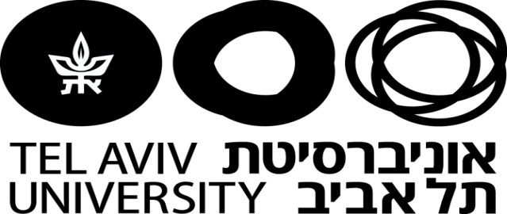

The Faculty of Humanities
The S. Daniel Abrahamfor International & Regional Studies
The Faculty of Social Sciences
The School of Political Science, Government, and International Affairs

A Conference on:
Populism and the Politics of Rage –
The Future of the Liberal Order
Monday, December 26th, 2016
The Lester and Sally Entin Faculty of Humanities,
Gilman Build ,Room 496
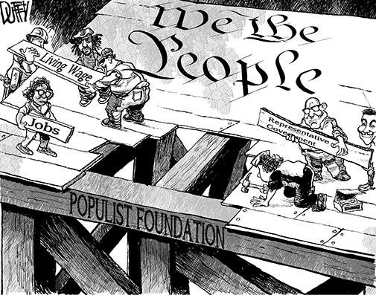

Free Admission

Program:

10:00 – 10:20 Gathering and Coffee
10:20 Opening Remarks and Greetings
Raanan Rein, Vice President, Head, The S. Daniel Abraham Center for International & Regional Studies
Yossi Shain, Head, The School of Political Science, Government, and International Affairs

Panel I 10:30– 12:30
Right wing populism and left wing populism in comparative perspective
Piero Ignazi, University of Bologna
Two variants of italian populism: The Lega Nord and the 5 Stars Movement"
Michael Kochin, Tel Aviv University
Class Struggle. From Aristotle to Trump
Raanan Rein, Tel Aviv University
Latin American Populism Revisited
Discussant :Sivan Hirsch, IDC Herzliya

12:30 – 14:00 Lunch Break

Panel II 14:.00 – 16:00
The new politics of rage. The democratic world and the resurgence of populism.
Federico Finchelstein, New School for Social Research, New York
Fascism and Populism
Alberto Spektorowski, Tel Aviv University
The rage against globalization. Betrayal of the elites or betrayal of democracy?
Dani Filc, Ben-Gurion University of the Negev
Rethinking populism in a populist age
Discussant: Hanna Lerner, Tel Aviv University

17:00 – 17:45 Gathering and Coffee – Last Session

Panel III 17:45 - 19:45
Resilience of liberal democracy?
Yossi Shain, Tel Aviv University
Is the U.S. still leading?
Joel Migdal, University of Washington
The American "We" and the Trump populist phenomenon.
Shlomo Avineri, The Hebrew University of Jerusalem
"Reading Tocqueville's " Democracy in America" in 2016
Yuli Tamir, President, Shenkar College
Populism or a new class consciousness
Discussant: Alberto Spektorowski, Tel Aviv University

